Experiment Report 1
Major： Grade Class
Name Student ID Score

1. Objectives
- Master Java coding standards, and understand how code style affects readability and maintainability.
- Learn to use CheckStyle and SpotBugs for static code analysis to detect potential bugs and style violations.
- Get familiar with Git version control and write clear commit messages.
- Interpret warnings from compilers and static analysis tools, and fix code defects independently.

2. Requirements

You are given a simple Java program for student score management with numerous style errors and hidden risks. Tasks:
- Register your gitee account and submit the raw code.
- Use IDEA to clone the initial code repository and create a new branch.
- Refactor the code according to Google Java Style Guide or Alibaba Java Coding Guidelines: fix naming, comments, indentation, blank lines, define constants and eliminate magic numbers.
- Import the CheckStyle configuration file and resolve all style errors.
- Scan the code with SpotBugs, and fix issues such as null pointers, unclosed resources and logical pitfalls.
- Make multiple commits with standardized commit messages, then merge the branch.
- Generate a comparison report before and after static checking.
- Mandatory Requirements:
- Do not suppress warnings unless you provide reasonable explanations in the report.
- Complete Javadoc comments for classes and critical methods.
- Submit Git log screenshots to demonstrate iterative modifications.

3. Result
(1) Baseline analysis: what the raw program looked like
The handout ships a single 35-line class named test in the package JavaCourse6. It mixes input, statistics and printing in main, uses one-letter names and keeps no documentation. The most serious problem is not cosmetic:
package JavaCourse6;
import java.util.*;
public class test {
public static void main(String[] args) {
Scanner sc=new Scanner(System.in);
int n; ...
int score[]=new int[n];
...
double avg=sum/n; // integer division before widening
With the sample input 90, 85, 66, 98, 77 the sum is 416 and n is 5, so the original program prints 83.0 instead of the correct 83.2. SpotBugs reported this as ICAST, which proves that the tool finds real defects, not only style noise.
Static analysis of the raw code:
Tool | Findings | Representative evidence
Checkstyle 10.12.4 | 117 warnings | WhitespaceAround 95, WhitespaceAfter 19, AvoidStarImport 1, TypeName 1 (class test), PackageName 1 (JavaCourse6)
SpotBugs 4.8.6 | 3 findings | ICAST integer division cast (line 18), DM_DEFAULT_ENCODING (Scanner, line 7), Nm class name not capitalised (lines 5-35)
Note on the supplied configuration: checkstyle.xml was written for an older Checkstyle and cannot even be loaded by 10.x. The original file is kept as checkstyle.original.xml; the runnable copy only adapts the configuration syntax (ignoreZero/ignoreOne -> ignoreNumbers, MagicNumber moved under TreeWalker, ImportOrder properties separated/ordered, allowMissingThrowsTags removed). No rule was weakened.
(2) Refactoring actions
Area | Before | After
Structure | everything inside main() | StudentScoreManager (statistics, 105 lines) + ScoreApp (console I/O, 95 lines)
Naming | test, sc, n, sum, t, avg | StudentScoreManager, Scanner, scoreCount, sum, swap, average
Magic numbers | 100 and 0 appear inline | MIN_SCORE, MAX_SCORE plus constants for every prompt and label
Validation | none: negative count crashes with NegativeArraySizeException | fail-fast IllegalArgumentException with a readable message
Encapsulation | the int[] is shared with the caller | defensive copy in the constructor, sortedDescending() returns a new array
Documentation | no comments at all | class-level Javadoc with @author, @param/@return/@throws on every public method
Formatting | braces glued to expressions, 4-space inconsistency | Google-style indentation, spaces around operators, one statement per line
Resources | Scanner never closed, platform default charset | try-with-resources and Scanner(System.in, UTF_8)
The refactoring was performed on a branch named refactor, one concern per commit, then merged back into master with --no-ff.
(3) Static checking before and after
Check | Before | After | Change
Checkstyle warnings | 117 | 0 | -117
SpotBugs findings | 3 | 0 | -3
Unit tests (JUnit 5) | not available | 7 / 7 passed | new safety net
The moved average is not a cosmetic change: fixing ICAST makes the displayed average match the arithmetic mean. Console output before the refactoring:
请输入学生人数
输入第0个学生成绩
...
平均分是83.0
成绩降序排列：
98 90 85 77 66
最高分：98
Console output of the refactored program with the same input:
请输入学生人数
请输入第1个学生的成绩（0-100）
...
平均分：83.20
成绩降序排列：
98 90 85 77 66
最高分：98
The full Checkstyle and SpotBugs transcripts are stored in reports/checkstyle-before.txt, checkstyle-after.txt, spotbugs-before.txt and spotbugs-after.txt.
(4) Git history
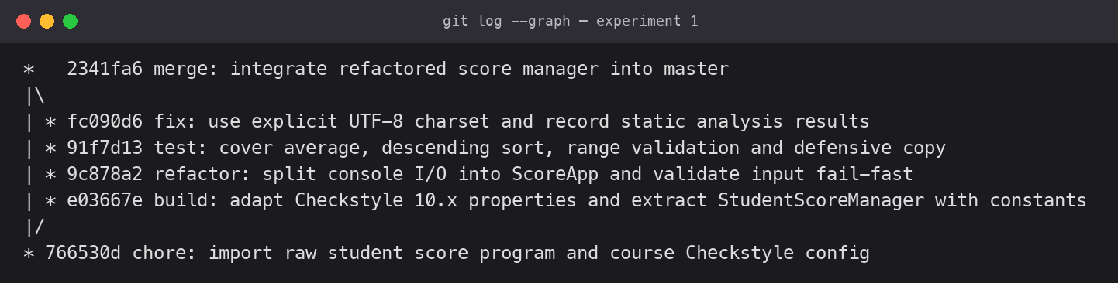
Figure 1. git log --graph: raw import, four refactoring commits on the branch, merge into master.
Commit messages follow the conventional-commit style (chore / build / refactor / test / fix), so each commit states why the change exists and not only what changed.
Repository layout: src/main/java/lab/score for production code, src/test/java/lab/score for the unit tests, reports/ for the analysis transcripts, and the untouched test.java as the baseline copy used for comparison.

4. Conclusion
Refactoring a 35-line program taught me that style rules and bug detectors look at different layers. Checkstyle removed 117 formatting and naming warnings, but SpotBugs found the defect that actually changed the result: integer division silently truncated the average. Writing Javadoc and constants forced me to name concepts instead of numbers. The biggest difficulty was the supplied configuration, which no longer loads in Checkstyle 10.x; adapting it showed that a rule set must be maintained like code. I also learned to commit one concern at a time, so every step stays reviewable.

